**Semiconductor fabrication and characterization**

**Practical file**

**Palak khanna**

**21HEL2159**

**B.Sc (H) Electronics**

**Semester 5th**

**Practical 1: Plot graph of polynomial equation:**

**PLOT-1:**

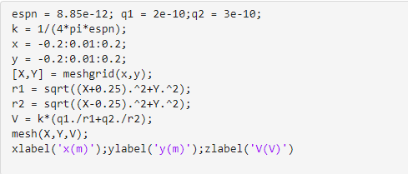

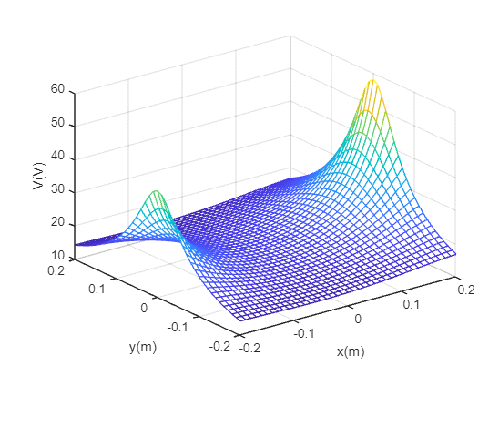

**PLOT-2:**

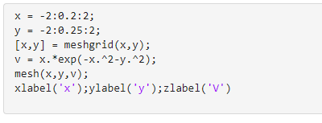

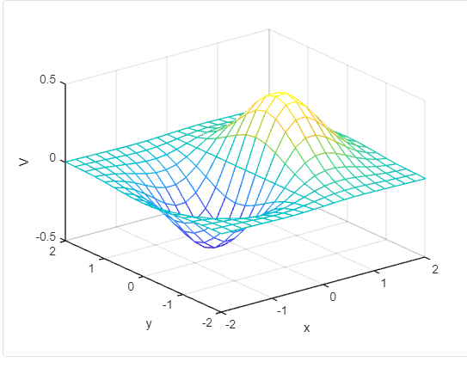

**PLOT-3:**

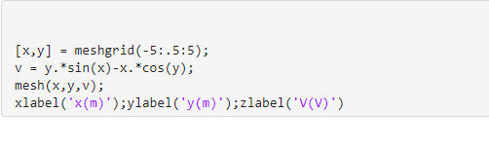

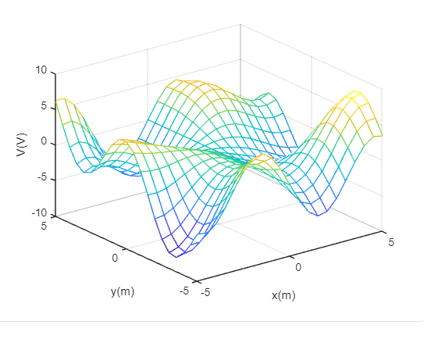

**Practical 2: Diffusion profiles**

1. **Constant Total dopant diffusion (CTDD)**

Code:

syms x

clc;

clear;

sqDt=0.1e-6;

x=0:0.001e-6:6e-6;

S=1e14;

CS=(1/(sqrt(pi)*sqDt))*exp(- x.^2/(4*sqDt*sqDt));

dCdx=-x.*S.*exp(-x.^2/(4*sqDt*sqDt))/(2*sqrt(pi)*sqDt*sqDt*sqDt);

plot(x, CS)

title('Constant-Total-Dopant Diffusion');

figure

semilogy (x, CS)

title('Constant-Total-Dopant Diffusion [Log Scale]');

figure

plot(x,dCdx)

title('Gradient of the Diffusion Profile');

Output:

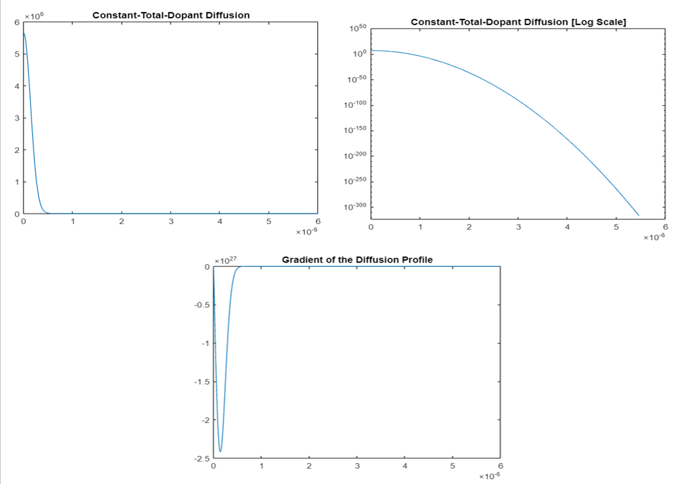

1. **Constant Surface concentration diffusion (CSCD)**

Code:

clc;

clear;

Cs=1e19;

sqDt=0.1e-6;

x=0:0.001e-6:6e-6;

CCs=erfc(x/(2*sqDt));

dCdx=-(Cs/(sqrt(pi)*sqDt))*exp(-x.^2/(4*sqDt*sqDt));

plot(x, CCs)

title('Constant-Surface-Concentration Diffusion');

figure

semilogy(x, CCs)

title('Constant-Surface-Concentration Diffusion [Log Scale]');

figure

plot(x, dCdx)

title('Gradient of the Diffusion Profile');

Output:

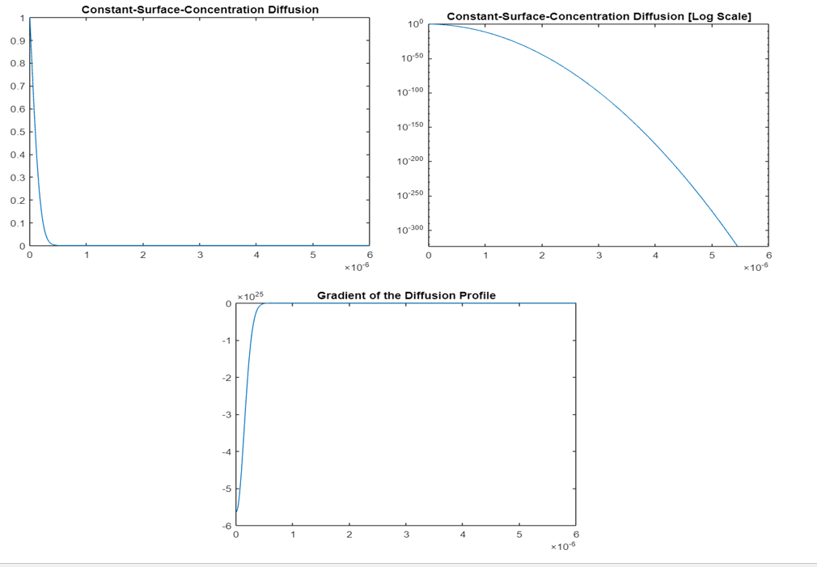

**Practical 3:** Surface Integral

**Code:**

syms x

a = sec(x)+exp(x);

b = int(int(a));

**Output:**

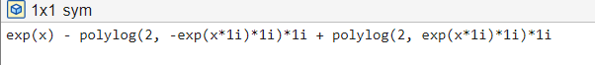

**Practical 4:** volume Integral

**Code:**

syms x

a = sin(x)+exp(x);

b = int(int(int(a)));

**Output:**

